**MAKERERE  UNIVERSITY**

**LABOR OPTIMIZATION SYSTEM**

By

BSE 20-25

MACHINE LEARNING

DEPARTMENT OF NETWORKS

SCHOOL OF COMPUTING AND INFORMATICS TECHNOLOGY

A Project Report Submitted to the School of Computing and Informatics Technology

For the Study Leading to a Project in Partial Fulfillment of the

Requirements for the Award of the Degree of Bachelor of

Science in Software Engineering of Makerere University

Supervisor

Dr. Moses Ntanda

Department of Networks

School of Computing and Informatics Technology, Makerere University

mntanda@cis.mak.ac, +256-7525-33355

DECEMBER, 2020

# Declaration

We, group BSE 20-25, hereby declare that the work presented is original and has never been submitted for an award to any university or institution of higher learning

|  |  |  |  |
| --- | --- | --- | --- |
| # | Names | Registration Number | Student Number |
| 1 | MUWONGE EMMANUEL | 16/U/7842/PS | 216003360 |
| 2 | SUNDAY DEOGRATIAS | 16/U/11792/PS | 216002567 |
| 4 | KISEMBO ERINAH TUMUSIIME | 16/U/6168/PS | 216007296 |
| 5 | MUTEBI WILSON | 16/U/7751/EVE | 216003599 |

Git repository: https://github.com/muwongeemmanuel/seemlos

# Approval

This project report titled Labor Optimization System has been submitted for examination with my approval as the supervisor of group BSE 20-25.

Dr. Ntanda Moses

Department of networks

School of Computing and Informatics Technology;

College of Computing and Information Sciences,

Makerere University

Signature: ................................................... Date: ............................

Supervisor

# Dedication

We dedicate this work to the almighty God for helping us push through all these four years. This work is also dedicated to our supervisor, whose input and guidance helped us complete this project. Finally we dedicate it to our parents, guardians and sponsors for all the financial and emotional assistance that enabled us complete our studies and this project.

# Acknowledgements

First, we would like to thank God the Almighty for blessing us with life, good health and the continuous financial provision throughout all the four years of this course till this stage.

We would like to thank our parents, guardians and friends for providing us with financial and moral support throughout the course of this program and project.

We also acknowledge with great appreciation our supervisor Dr. Moses Ntanda who guided us throughout the conception, realization, design and completion of this project. She has been very supportive and present whenever we needed her.

Finally, we thank our fellow students for always being supportive, updating us about the relevant class information and contributing to our newly learnt skills during the development of this project.

# Abstract

The Labor optimization System will provide a solution to the problem of labor underutilization and labor over utilization in many organizations in Uganda which may at first not seem as a big issue to business and yet it actually is.

Labor is a factor of production and therefore it equally affects the growth of a business just as much as any other factors such as capital and land. Labor as a resource is mainly measured in terms of labor productivity which is a key measure for business efficiency. Uganda has lowest labor productivity of 1,085 in comparison to its neighboring countries (Tanzania 2,016; Zambia 2,680; Kenya 3,457) in terms of value added per worker in US dollars. This therefore lowers the economy of the country despite the fact that we are undergoing the industrial revolution. Following the National Employment Policy of the republic of Uganda which states that Increasing Decent Employment Opportunities and Labor Productivity for Socio - Economic Transformation, this much more causes a great need for the improvement of the labor productivity as this is of great importance to both the business and the country at large.

The UBOS report suggests use of technology as one of the solutions to the decrease in labor productivity. The LOS system will be developed to provide a solution to the problem in the above paragraph. It will be a web based system with a machine learning predictive model that can predict the amount of work and distribute it basing on the labor available. It will also help in the business analysis.

**System implementation, testing and validation report for SEEM Labor Optimization System**

|  |  |
| --- | --- |
| Document No: |  |
| Prepared by: | BSE20-25 |
| Date: | 01-12-2020 |
| Version: | 1.0 |

Document Approval

|  |  |  |  |
| --- | --- | --- | --- |
| **Name** | **Role** | **Date** | **Signature** |
| <Author> | Author(s) |  |  |
|  | Validation |  |  |
|  | Client |  |  |

Table of Contents

Declaration i

Approval ii

Dedication iii

Acknowledgements iv

Abstract v

Chapter 1: Introduction 1

1.1 Background and scope of the project 1

1.2 Overview of the document 2

Chapter 2: System Specifications 4

2.1 Version of requirements and Version control 4

Version of requirements 4

2.2 Input 4

2.3 Output 4

2.4 Functionality 5

2.5 Limitations and safety 5

2.6 Default settings 5

2.7 Special Requirements 5

2.8 Errors and Warnings 5

Chapter 3: Design Output 6

3.1 Implementation 6

3.2 Documentation 7

Chapter 4: Inspection and Testing 9

4.1 Introduction 9

4.1.1 Inspection plan and performance 9

4.2 Test Plan and Performance 11

4.2.1 Test Objectives 11

4.2.2 Scope and Relevancy of Tests 11

4.2.3 Levels of Tests 11

4.2.4 Types of Tests 11

4.2.5 Sequence of Tests 12

4.2.6 Configuration and Calculation tests 12

4.3 Precautions 13

4.3.1 Anomalous Conditions 13

4.3.2 Precautionary steps taken 13

Chapter 5 Installation and System Acceptance Test 14

5.1 Input Files 14

5.2 Supplementary Files 14

5.3 Installation Qualification 14

Chapter 6: Performance, servicing, maintenance, and phase out 16

6.1 Service and maintenance 16

6.2 Performance and Maintenance 16

Chapter 7: Conclusion and Recommendations 18

Appendix A: User Manual 19

References 23

**List of Figures**

Figure 1 The landing page 19

Figure 2 The default analysis page 20

Figure 3 Analysis 1 20

Figure 4 Analysis2 20

Figure 5 Analysis 3 21

Figure 6 A prediction screen 21

Figure 7 Admin page for adding new users 22

**List of Tables**

Table 3. 1 Design Output Checklist 7

Table 4. 1 Inspection Plan and Performance 9

Table 4. 2 Sequence of Tests 12

Table 5. 1 Checklist of the Installation and system acceptance test 14

Table 5. 2 Installation and Procedure Check 15

Table 6. 1 Performance and maintenance details 16

# Chapter 1: Introduction

## 1.1 Background and scope of the project

The Labor Optimization System – LOS provides a solution to the problem of labor underutilization and over utilization in organizations. The Labor Optimization System will provide a solution to the problem of labor underutilization and labor over utilization in many organizations in Uganda.

Labor is a factor of production and therefore it equally affects the growth of a business just as much as any other factors such as capital and land. Labor as a resource is mainly measured in terms of labor productivity which is a key measure for business efficiency. [1]Uganda has lowest labor productivity of 1,085 in comparison to its neighboring countries (Tanzania 2,016; Zambia 2,680; Kenya 3,457) in terms of value added per worker in US dollars. This therefore lowers the economy of the country despite the fact that we are undergoing the industrial revolution. [2]Following the National Employment Policy of the republic of Uganda which states that Increasing Decent Employment Opportunities and Labor Productivity for Socio - Economic Transformation, this much more causes a great need for the improvement of the labor productivity as this is of great importance to both the business and the country at large. [3]

[4]The UBOS report suggests use of technology as one of the solutions to the decrease in labor productivity. The LOS system will be developed to provide a solution to the problem in the above paragraph. It will be a web-based system with a machine learning predictive model that can predict the amount of work and distribute it basing on the labor available. It will also help in the business analysis.

The LOS system seeks to solve the above problem by using a predictive machine learning model which predicts the workload at hand at a given time which information can then be used to estimate the amount of labor required in a given data following the company’s employee to customer ratio. The system is also to analyze the data of the organization to help give a better understanding of the data at hand and the decision-making process of the company.

In order to use the system, the user will be required to sign into the system using details that are provide by the admin, who can create and delete a use account. The user then can access the predictive and the analytical modules of the system. The predictive module predicts the amount of work in form of patients for a given day, number of days, weeks or months. Therefore, the user will be required to input the number for which he/she needs to know the anticipated workload. After getting this, user can then use the information to estimate the amount of labor needed. The analytics module on the other hand is a dashboard displaying the data in the connected database in terms of graphs and tables. The user will basically be required to click the various buttons on the dashboard which display the data he/she needs to see.

## 1.2 Overview of the document

This document describes the implementation, testing and validation findings for the LOS system. It is divided into the following sections:

**Section 1: Introduction**

This section gives an overview of the LOS system. It describes the different features of the entire application and the functionality offered by each feature to the application.

**Section 2: System Specifications**

This section describes and specifies the system completely and is the basis for the validation process. It includes the version of requirements and version control, input, output, functionality, limitations and safety, default settings, special requirements and errors and alarms.

**Section 3: Design Output**

This section describes the development tools used to implement the system notes on the anomalies, module and integration details of the system. The section also entails a description of all the device interfaces and equipment to be supported.

**Section 4: Inspection and testing**

This section describes the system inspection and testing plan and documentation of the test plan. It also contains the test objectives and types, configuration tests and calculation test.

**Section 5: Installation and system acceptance test**

It describes the installation and system acceptance tests. It details all relevant files supplementary files, the installed components and the installation qualification that the users must possess to use the application.

**Section 6: Performance, servicing, maintenance and phase out**

This section contains descriptions of performance, servicing, maintenance and phase out stages. It describes the different problems that may be encountered in the use of the system and the possible solutions to overcome those problems.

**Section 7: Conclusion and recommendations**

This section summarizes the whole project and makes remarks and highlights several issues about the project.

# Chapter 2: System Specifications

## 2.1 Version of requirements and Version control

This is the first release of the LOS system and the version of the application is labelled version 1.0 and it includes the features described in section 1.1. Though some of the requirements of the systems were changed during the system development.

### Version of requirements

1. Version 1.0

Included an interface for the users enter data and be inserted into the database which data was to be collected and be used by the analytics module and also for keeping the predictive model up to date.

1. Version 1.1

Removed the user interface for inserting data into the database and concluded on using already existing data for both the predictive and analytics modules.

## 2.2 Input

The following are the system inputs according to the requirements specification document.

The system has got two modules, the predictive module and the analytic module.

Login details: The system will require the use to input a correct username and password before using it.

Day, week, month: For the predictive module, the inputs are day, week and month for which one needs to get a prediction.

Data: the analytical module, uses the data from the database as its input.

## 2.3 Output

The system gives the following output:

Predictions: The predictive module of the system will output predictions in form of numbers, basing on what the input requires to be predicted.

Analytical dashboard: the analytic module is to output an analytics dashboard that displays the analytics of the data input.

## 2.4 Functionality

The LOS system has majorly two functionalities:

1. Predicting the work load for a given day, the LOS system predicts the amount of work load available for a given day in term of patients. The user can input a day, week or month depending on the required prediction.
2. Analyzing data, the LOS system analyses the data in the system database and displays it on the dashboard in form of graphs and tables. The analysis is to help with the proper understanding of the various business processes.

## 2.5 Limitations and safety

The analysis module will require to first be connect to a database that contains the data to be analyzed. This database must contain the data that was/is to be used in creating the predictive model.

## 2.6 Default settings

When first installed, the system will only have one username and password for the administrator, who can then register the other different users in the system following the company policy.

The analysis module on reload will give analysis of the most recent data in the database.

## 2.7 Special Requirements

The system requires that there is an already built database from which we are pick the data for analysis and also the csv to build and update the built model.

## 2.8 Errors and Warnings

The system errors are caught as exceptions while coding and the possible errors due to user interaction are either caught or warning are flagged off to the user to reminder them input the right data or ask a different type of user to perform a given task on the system.

# Chapter 3: Design Output

## 3.1 Implementation

The Labor Optimization System has three components: the web app, the API and the predictive model which have all been developed using the python programming language because it’s supports deep learning, readable and efficient for creating front and back ends of a web- based system with greater interoperability. Python is also an open source, cross platform language with a standard library and a rich supportive Community.

The Web app (user interface) has been developed using Django python framework and bootstrap. The API component has been developed using flask which is a lightweight python framework. The predictive models were developed using Jupyter notebook in anaconda environment. We used MySQL database (a free to use open source database, stable, reliable with advanced data security) to store the dataset we used for analysis.

The system has three predictive models to predict daily, weekly and monthly workload. They have been developed using TensorFlow using the Keras which required TensorFlow deep learning framework for developing machine learning applications. TensorFlow is a low-level library used for developing neural networks. We used the Keras deep learning framework because it’s high level API with strong multiGPU support and distributes training support and makes it easier to deploy models across a great range of platforms than any other deep learning framework.Keras is user friendly and easy to use when built on top of TensorFlow compared to its alternatives.

Tools like Git and GitHub were used for version controlling so that all changes of the software code can be tracked. We also used visual studio code and Jupiter notebook as our IDE and Jupiter notebook for training our model.

The system components where integrated in such a way that the web app receives user input and forwards it to the API to process the input and return the required output that the web app receives and displays it to the user. The predictive model is embedded in the API. In case the received input has to be processed by the neural model, the API interacts with the necessary predictive model to process the input and return the required output that the API receives and forwards it to the web app that displays it to the user.

## 3.2 Documentation

Our system has user manual and the design documents that we have generated as our output from the design. The user manual document gives details of how the Labor Optimization System can be used and the design document gives details of how the system was designed. The readers of these documents will have to read them according to what they want to know about the system.

The design details of the system about the programming practices and dynamic tests we used have been shown in the table below.

Table 3. 1 Design Output Checklist

| **Topics** | **Design output** | |
| --- | --- | --- |
| **Good programming practice** | Source code is... | Source code contains... |
| **Windows programming** | Comments: | |
| **Dynamic testing** | Comments: | |

# Chapter 4: Inspection and Testing

## 4.1 Introduction

The inspection and testing of the Labor Optimization System was planned and documented in a test plan. The ex­tent of the testing is in compli­ance with the requirements, the system acceptance test specification, the approach, complexity, risks, and the in­tended and expected use of the system*.*

Table 4. 1 Inspection Plan and Performance

| **Topics** | 4.1.1 Inspection plan and performance | **Date / Initials** |
| --- | --- | --- |
| **Design output** | Comments:  Tested and agreed upon by team members | 4/11/2020  E.K  S.D  M.E  M.W |
| **Documentation** | Comments:  No user manual but online blog to help | 4/11/2020  E.K  S.D  M.E  M.W |
| **Software development environment** | Comments: | 5/11/2020  E.K  S.D  M.E  M.W |
| **Result of inspection** | Comments:  Inspection was approved by system developers and project supervisor | 6/11/2020  E.K  S.D  M.E  M.W |

## 4.2 Test Plan and Performance

### 4.2.1 Test Objectives

The test was conducted to check whether the system conform to the requirements and the system acceptance test specification. The system was tested under both development and production environment conditions. The system documentations, source code and running system were all tested to see whether they conform to the set requirements and usability and user acceptance standards.

### 4.2.2 Scope and Relevancy of Tests

The system was tested starting from Requirements documents, Design documents against which the system source codes, structures, inputs and outputs were tested. Using the mentioned documents was relevant in reaching the final user acceptable system.

### 4.2.3 Levels of Tests

Module Test: Here the system modules namely Data, Analysis and Predictive Model and User Interface were each tested for optimum functionality.

Integration Testing: The three modules were integrated to form a complete system. The integrated system was then tested to see that the combined modules are working together to realize the overall functionality of the system.

System Acceptance Testing: Inputs and outputs were tested using predefined parameters. This was conducted on the fully integrated running system. This was done so that the system conforms to the user requirements.

### 4.2.4 Types of Tests

Input: Different inputs were tested to check whether relevant predefined outputs are realized.

Functionality: Here all the functionalities specified in the system requirements were tested for availability.

Performance: The system was tested basing on the following performance parameters; user satisfaction, average response time, error rates, request rate, application and server CPU, application availability.

Usability: The system was also tested against usability parameters for effectiveness, efficiency and satisfaction.

### 4.2.5 Sequence of Tests

Table 4. 2 Sequence of Tests

|  |  |  |  |
| --- | --- | --- | --- |
| Test Case | Test Procedure | Test Data | Expected Results |
| Test predictive model for accuracy | 1. Insert training data into the model 2. Use ML accuracy testing algorithm to output accuracy value | A cleaned dataset | Accuracy of above 75% |
| System Response Time | 1. User clicks on the “prediction” button 2. User waits for response | N/A | Average response time should be less than one second on local host |

### 4.2.6 Configuration and Calculation tests

Platform: The system was tested to see how it performs after it is hosted on the database and web hosting servers.

Network testing to check for internet and network security. Calculation tests confirm that known inputs lead to specified outputs.

## 4.3 Precautions

### 4.3.1 Anomalous Conditions

New dataset used by organizations not up to standard requirements.

Organizations database servers being slow.

### 4.3.2 Precautionary steps taken

Inherent system checks for new data from organization for conformity to set standards

Resorting to lightweight database to host the dataset that the system maybe using at a particular time

# Chapter 5 Installation and System Acceptance Test

## 5.1 Input Files

Fully integrated system files for hosting on a web server

## 5.2 Supplementary Files

Read Me Files

License Agreements

## 5.3 Installation Qualification

Table 5. 1 Checklist of the Installation and system acceptance test

| *Topics* | **Installation summary** |
| --- | --- |
| **Installation method** | Comments: |
| **Installation media** | Comments: |
| **Installed files** | * HTML files * HEX files * CSS files * Python files * CSV files |

Table 5. 2 Installation and Procedure Check

| *Topics* | **Installation procedure** | *Date / Initials* |
| --- | --- | --- |
| **Authorization** | Person responsible:  Muwonge Emmanuel | 8/11/2020  M.E |
| **Installation test** | Comments:  System tested by all project members with guidance from supervisor | 8/11/2020  M.E  S.E  K.E  M.W |

# Chapter 6: Performance, servicing, maintenance, and phase out

## 6.1 Service and maintenance

We are hopeful of keeping hold of the project and try to improve it with time.

We plan to keep track of the users’ experiences. This in turn, will enable us to be able to get to know where we need to change and where to uphold. We plan to add some new features and modify the present ones so as to ensure that the users are having the perfect experience of the system.

We plan to have timely quarterly updates with a view of keeping the system with the best user experience for its users. These updates will be consisting of system upgrades to newer versions with the user feedback taken in to modification plus other changes resulting from modifying code to ensure that the system is faster and more reliable.

## 6.2 Performance and Maintenance

Table 6. 1 Performance and maintenance details

| *Topics* | **Performance and maintenance** | *Date / Initials* |
| --- | --- | --- |
| **Problem / solution** | Our first burden is to try and fix all the probable problems that are found out shortly before and after deployment. This means that we need to keep in touch with the users of the system. | Dates must be filled. |
| **Functional maintenance** | This system is subject to the user’s demands and is meant to adapt to what the users demand of it |  |
| **Functional expansion and performance im­provement** | 1. Look for areas where we can improve on code used so achieve a faster website 2. Updating some packages used with time so as to ensure the system earns from the improvements made in the source code used. |  |
| **Model Improvement** | The system’s model is meant to be improved and optimized with time. This requires that we be updating the database daily. In this way the system is able to keep up with the trends in the data. |  |
| **User Experience Improvement** | The system’s outlook is meant to be continually updated with feedback from the end users. This is to enable us ensure that the users have a wonderful; experience of the system. |  |
| **Additional Features** | The system, is meant to have new features based on the users’ feedback. These new features are meant to cover for the user’s needs that are discovered later. |  |

# Chapter 7: Conclusion and Recommendations

This report validates all the documented and approved activities that have been done to develop and test the Labor Optimization System. This is evident with the subsequent signatures of approval for the project.

# Appendix A: User Manual

The system loads to a landing page which includes the user log in and a brief description of the system.

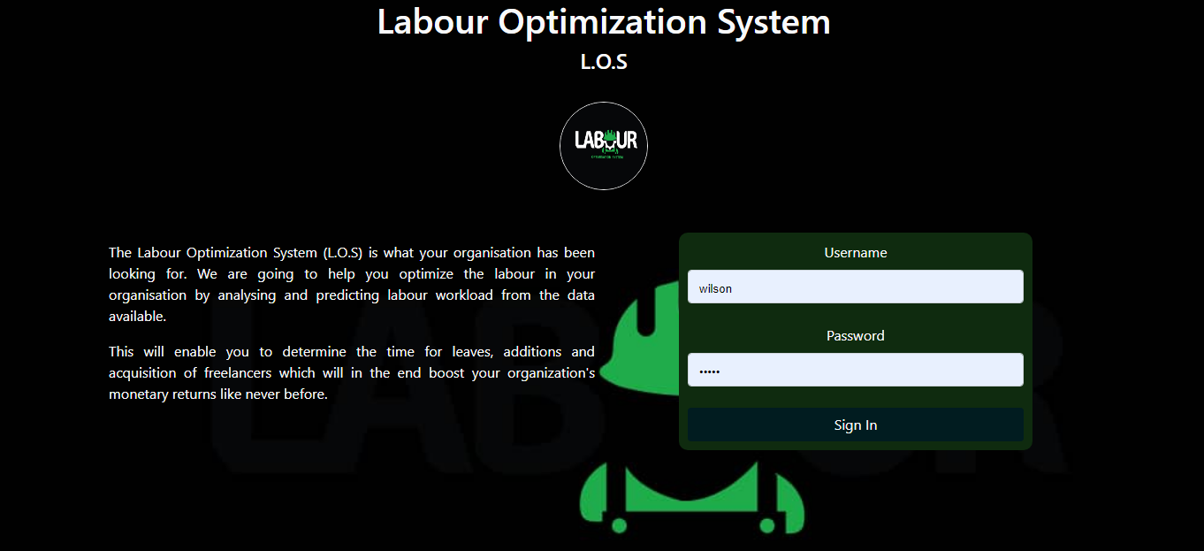

Figure 1 The landing page

The user logs in with a credential provided by the system administrator and is met with the below interface, which consists of the different menu and analysis page as the default page. More analysis pages are shown basing on user requests. The interfaces are shown below.

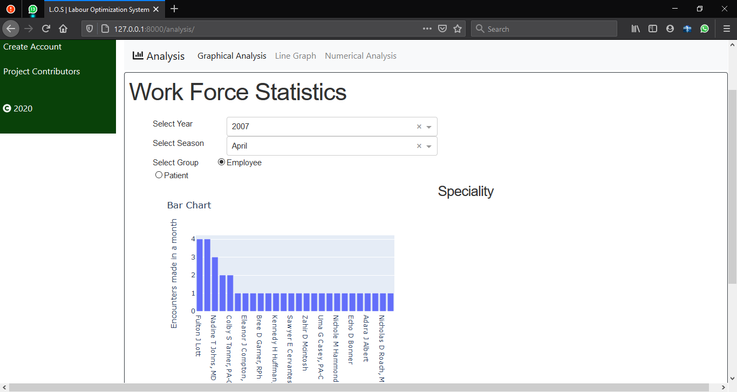

Figure 2 The default analysis page

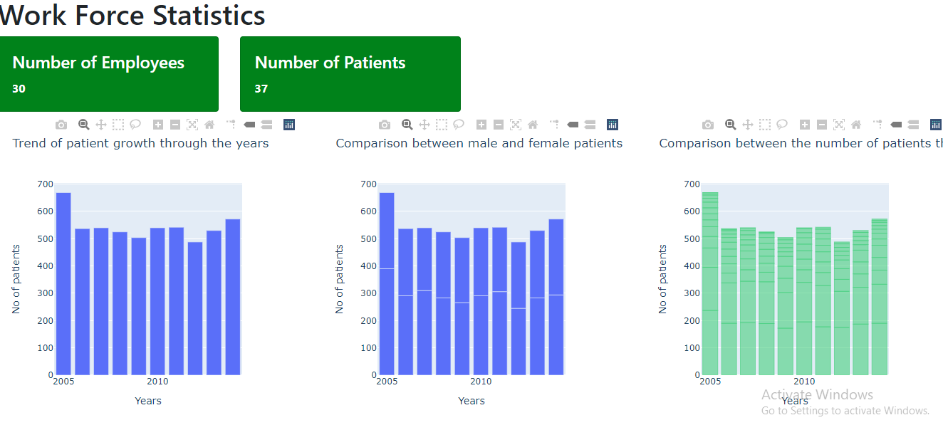

Figure 3 Analysis 1

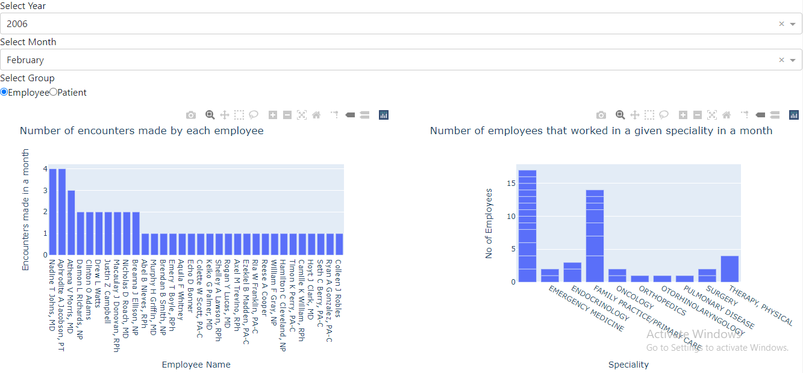

Figure 4 Analysis2

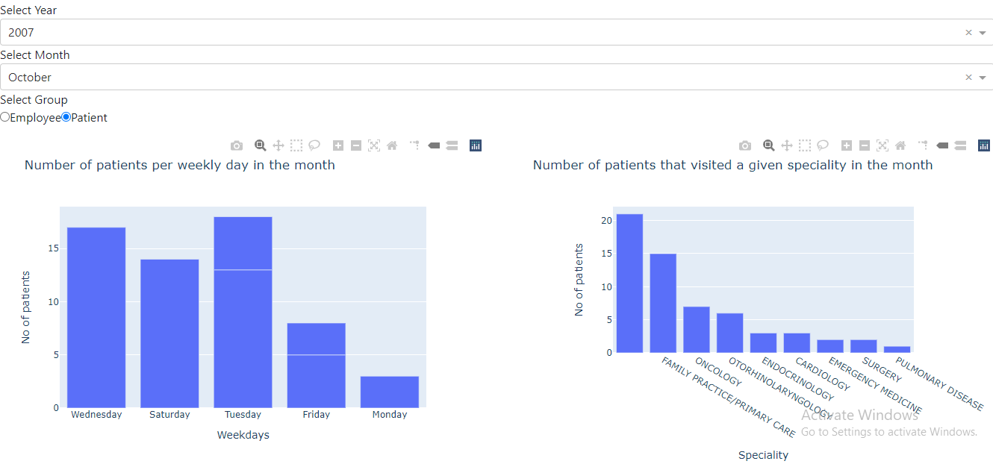

Figure 5 Analysis 3

The user once logged in can manipulate the analysis menu options by selecting the monthly or yearly options, and also decide whether to perform analysis based on Employees or Patients.

When the user selects the prediction menu option, he or she is requested whether the predictions should be monthly or daily. Depending on the option chosen, a page similar to below is displayed.

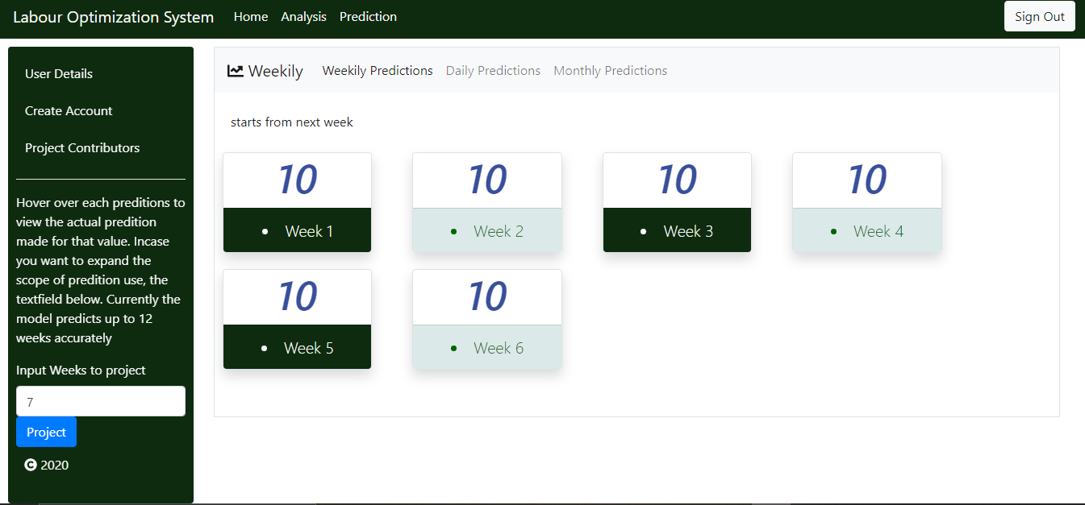

Figure 6 A prediction screen

It should be noted that only the admin has a default log in and its only him/her that can add new users using the screen below.

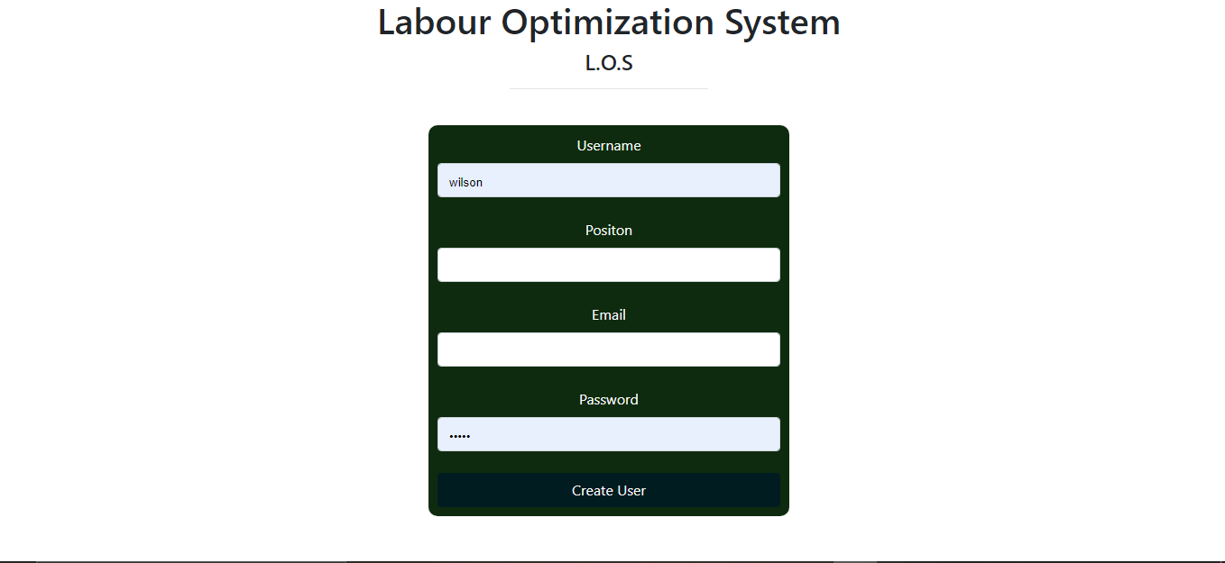

Figure 7 Admin page for adding new users

Our system provides a rich menu options that can be explored once logged in. The screenshots above provide brief highlights. We hope you enjoy using our system

# References

|  |  |
| --- | --- |
| [1] | Ssemwogerere, "Productivity Performance in Developing Countries 2009.," [Online]. |
| [2] | "THE NATIONAL EMPLOYMENT POLICY FOR UGANDA," [Online]. |
| [3] | [Online]. Available: Available: https://newz.ug/uganda-will-not-achieve-middle-income-status-with-the-current-low-labour-productivity/.. |
| [4] | Ubos, "Ubos, Report national labour force survey 2017," [Online]. |